Pion-LT E12-19-006

Summer 2022
8.487 GeV Run Plan
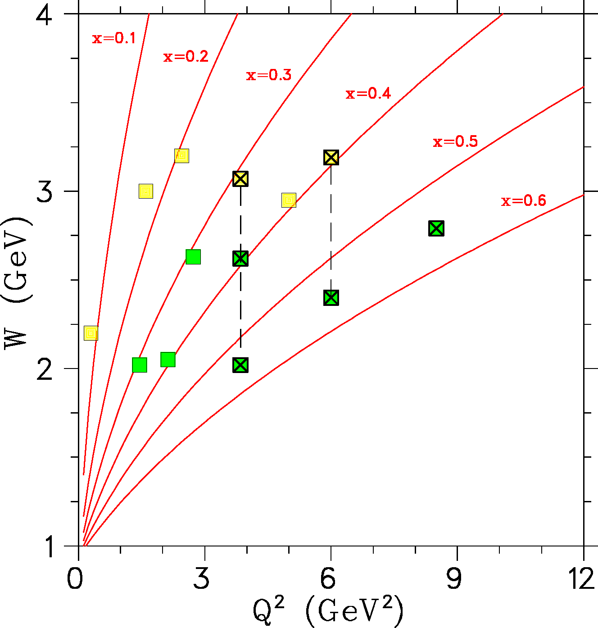
W versus Q2 settings planned for the “Fπ experiment” (yellow squares) and the “Pion
Scaling experiment” (green squares). The points instrumental in the higher Q2 Fπ extraction are indicated with ‘X’. The red lines indicate fixed x values from 0.1 to 0.6. The dashed lines denote scans in t at fixed Q2, which will be used to evaluate the dependence of the Fπ extraction on t.

